**Task 10 – Protein Chemistry Quiz Name: _______________________**

Answer the following questions in the spaces provided. You have been supplied a Data Sheet and a copy of the “Biuret Test for Proteins”.

1. Explain with the assistance of diagrams the difference between a monosaccharide and disaccharide. (4 marks)
2. The formation of sucrose can be considered a type of polymerisation reaction. Explain why it can be considered as this type. Make sure you use diagrams and name the specific type of reaction. (4 marks)
3. Consider the following diagram.

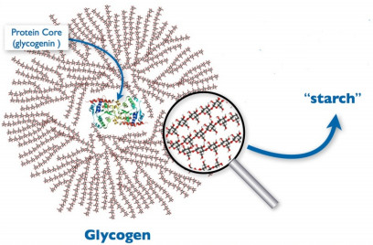

Explain with reference to the above the difference in solubility in water between starch and glycogen. (2 marks)

1. Name the simplest amino acid and draw its molecule. (2 marks)
2. Forming a peptide bond can occur between two amino acids. Draw the molecular reaction between asparagine and glycine. Indicate clearly where the peptide bond is located.

(3 marks)

Consider the **“Biuret Test for Proteins”** booklet and answer the following questions.

1. What are a “negative control” and a “positive control”? Why do you use them in an experiment?

(2 marks)

1. Explain why the following step is in the procedure. (1 mark)



1. Draw the biuret molecule. (1 Mark)
2. Why does the biuret solution change colour? (1 mark)
3. As the biuret solution is added to a protein a colour change occurs. With reference to stoichiometry, explain why the degree of colour changes is dependent upon the amount of protein present. (2 marks)
4. In the Biuret Test for proteins using the Biuret Reagent, identify the:

(3 marks)

1. The independent variable: ________________________________
2. The dependent variable: ________________________________
3. 3 controlled variables: ____________________________

____________________________

____________________________

1. What is a chelate complex? (1 mark)
2. Is the Biuret Test a qualitative test or quantitative test? Why? (2 marks)

**END OF Task 10 Quiz: TOTAL: _____/ 28 Marks**